## Assignment Tasks (Module 4 Part 1-4)

## Instructions

* **CREATE the SQL script file for the following questions using the Walnut Grove Bank (WGB) database as found in the Course Content 🡪 Course Resources 🡪 Databases section of D2L. Create a spool file (*ass1_result.txt*) of all of your SQL commands.**
* **Submit the SQL Code and spool file via D2L under the appropriate assignment.**
* **Set echo, linesize, and pagesize at the beginning of SQL script file.**

**Q1)**

Show all customers who created accounts in the month of July. Include customer_number "Cust #", account_type "Account Type", date_created "Date" and Address. Demonstrate the use of replace function in address so as to change ‘Apt’ to “Apartment”. Sort your records by customer_number.

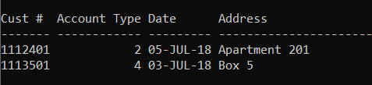

**Q2)**

Show the balance of each **“Chequing” accounts**. Display first name “First”, surname “Last”, phone “Phone”, customer number “Cust #”, account type “Type” and balance “$”. Sort the records by surname, first_name, customer_number and account_type. Note: Demonstrate the use of “**Traditional Join**”

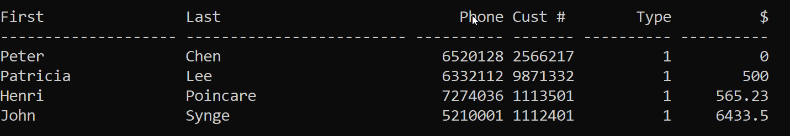

**Q3)**

Show the balance of each **Daily Interest Savings accounts**, include first_name "First", surname "Last", phone "Phone", customer_number "Cust #", account_type "Type", balance "$". Sort by surname, first_name, customer_number and account_type. Note: Demonstrate the use of “**Join …. ON**”.

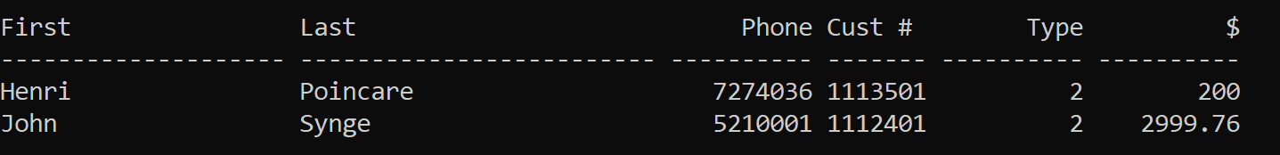

**Q4)**

List the customer’s first_name "Name", account_description "Description", balance and all associated transactional information (transaction_date "Date", transaction_amount "Amount"). The result should only include accounts whose account description contains the word “Interest”. Apply left padding to Amount with ‘*’ to a width of 9 characters. Note: Demonstrate the use of “**Traditional Join**”

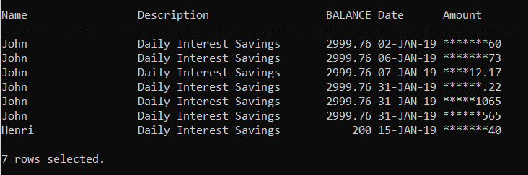

**Q5)**

Show the name of all persons and their customer numbers. Include the first name, last name, customer number, date created “Date” and type of account in the output. Change date created from the format DD-MM-YY to the format DD/MM/YY. Sort by last name, first name, customer number and type. Note: Demonstrate the use of “**Join Using**”

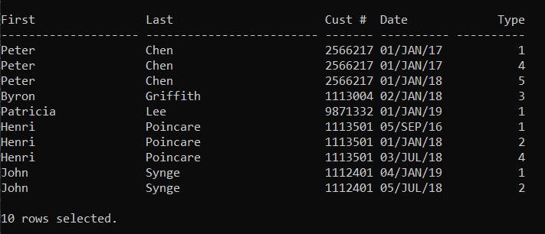

**Q6)**

Display all customers, their customer #, account types and opening balances by using JOIN...USING. Sort by first name and then by type in descending order. Opening Balance must be in $99,990.00 format. Use exact match CASE to change the account type to the following abbreviations:

|  |  |
| --- | --- |
| **Account type** | **Abbreviations** |
| 1 | Chq |
| 2 | Daily Sav |
| 3 | Mthly Sav |
| 4 | RRSP |
| 5 | GIC |

